**SG Technologies**

**Software Architecture Document**

**SAD for POS System**

**Keith Bell, Rafael de Oliveira,**

**Nicholas Gennuso, Jianing He, Chang Sun, Qiran Ying**

**CSE 216**

**6 October 2015**

**Abstract:**

This document is the first iteration of the Software Architecture Document (SAD) for the POS System developed by SG Technologies. This iteration of the SAD concludes the Elaboration phase of this project and includes 3+1 architecture views reflecting our five use cases for our system.

The use case view provides system sequence diagrams of each use case and captures system functionality as seen by users. The logic view, for which we currently have three class diagrams and one package diagram, specifies the functional requirements of the system. The data view provides activity diagrams which show the flow of information throughout the program. Lastly, the deployment view outlines the physical specifications of the product.

We have also provided a Responsibility Matrix (RM) and Work Breakdown Structure (WBS) in the SAD. The RM is a tool the team used when first planning the Elaboration phase and along the way to maintain whose responsibility is whose for each artifact of the document. The WBS was planned at the beginning of the phase as well, but updated during the process so that the team could document when things were getting done and assess the duration of different tasks.

This document, along with a working prototype, provides a rough layout of the architecture of the POS System. With this being said, SG Technologies acknowledges that there is work to be done on formatting, uniformity, and completeness that will come later in the Construction and Transition phases of the project and we look forward to more progress being made.

**Architecture Views**

**+ Use Case View: System Sequence Diagrams**

Process Sale

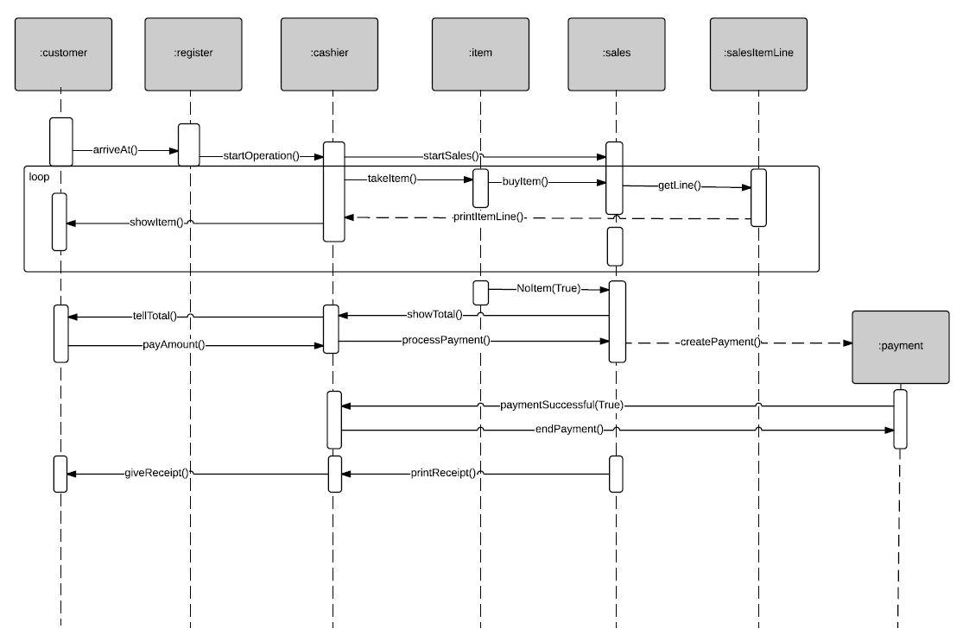

Process Return

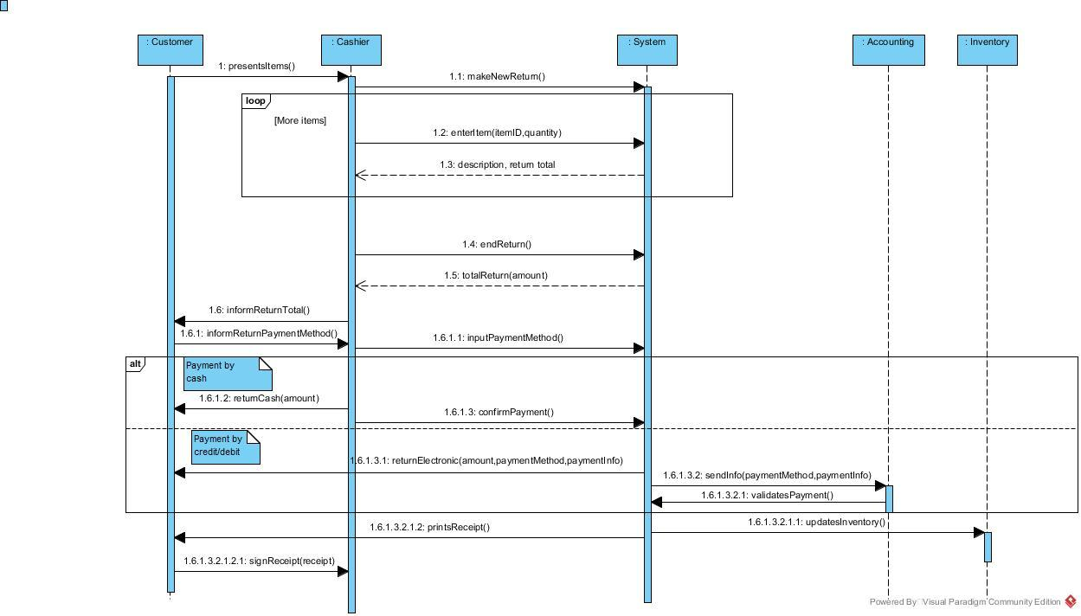

Process Rental

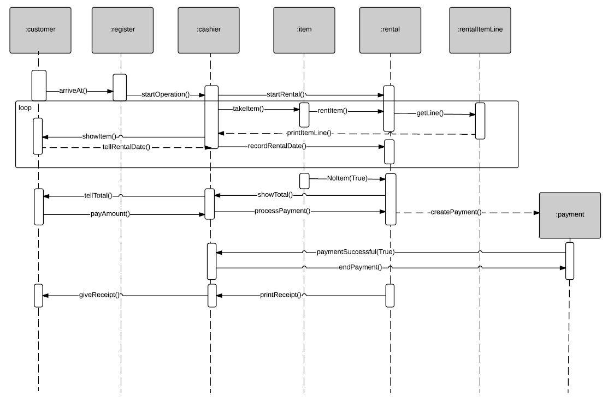

Startup/Shutdown

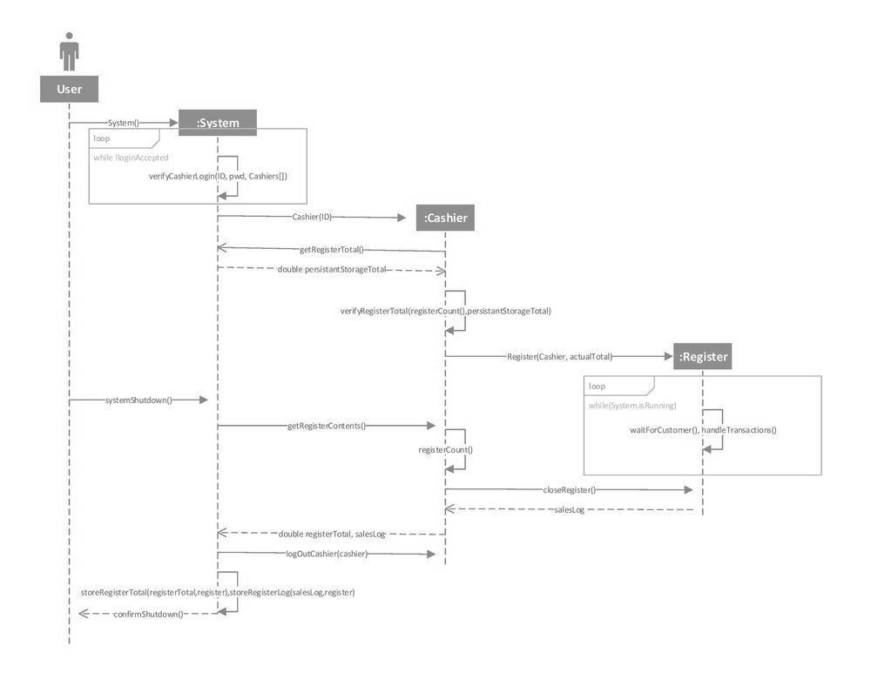

User Management

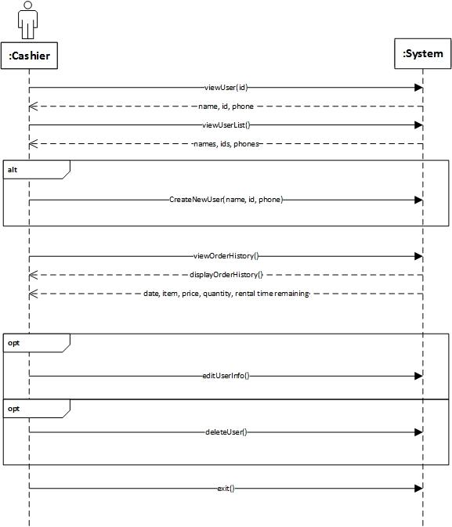

**+ Logic View: Package Diagram**

**Class Diagrams**

Process Sale

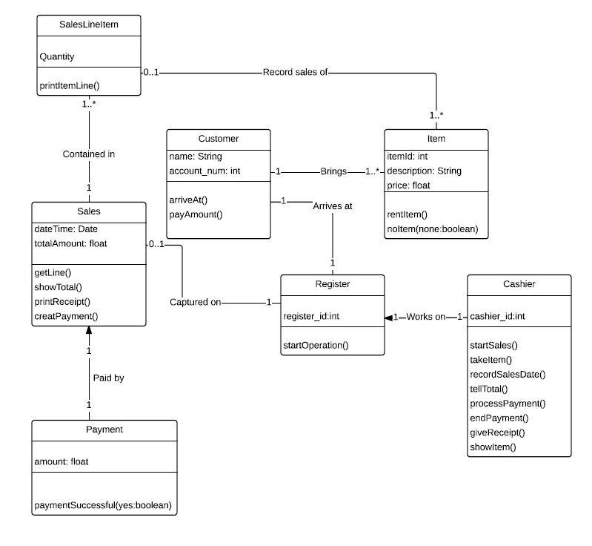

Process Return

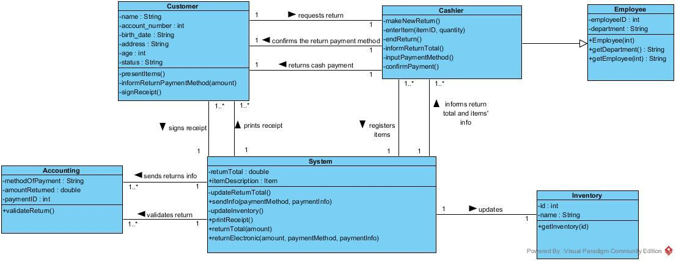

Process Rental

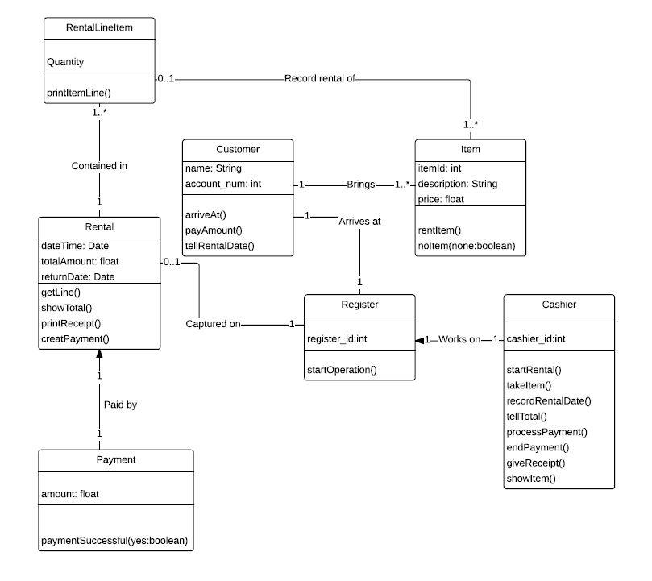

**+ Data View: Activity Diagrams**

Process Sale

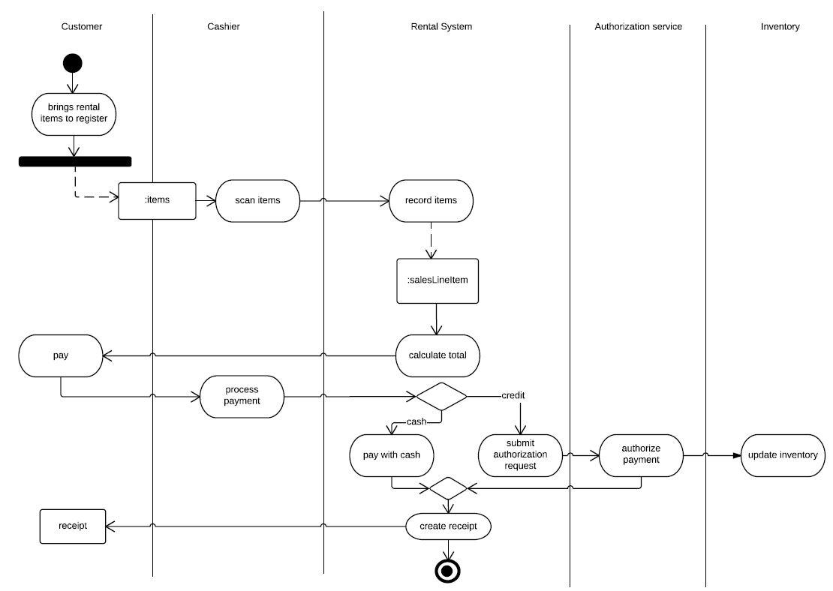

Process Return

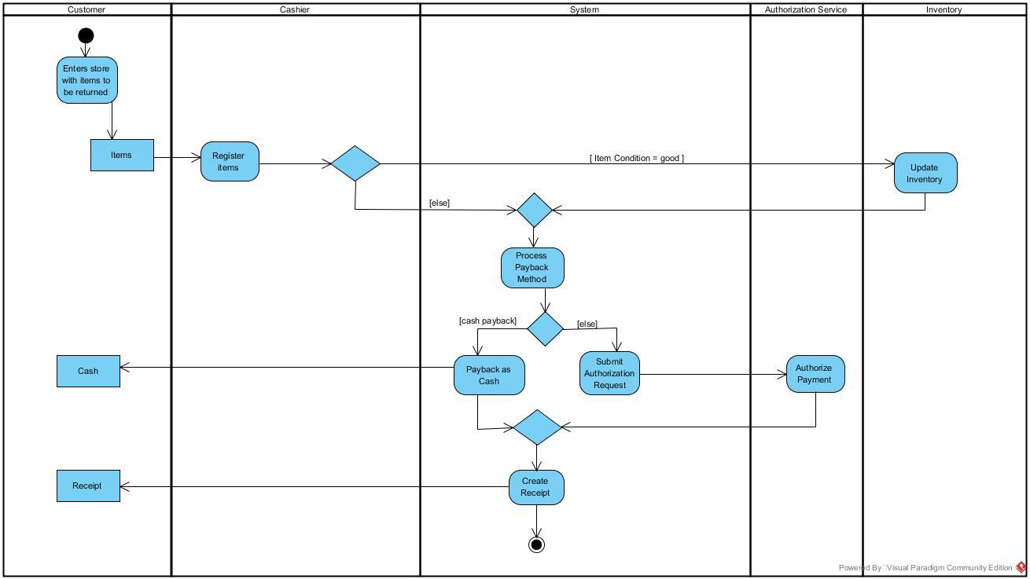

Process Rental

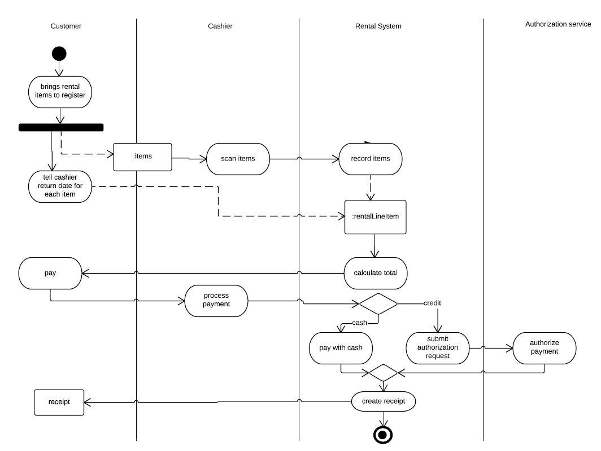

Startup/Shutdown

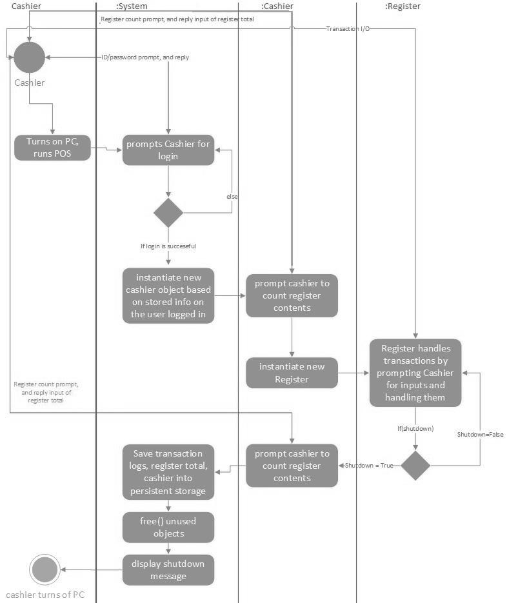

User Management

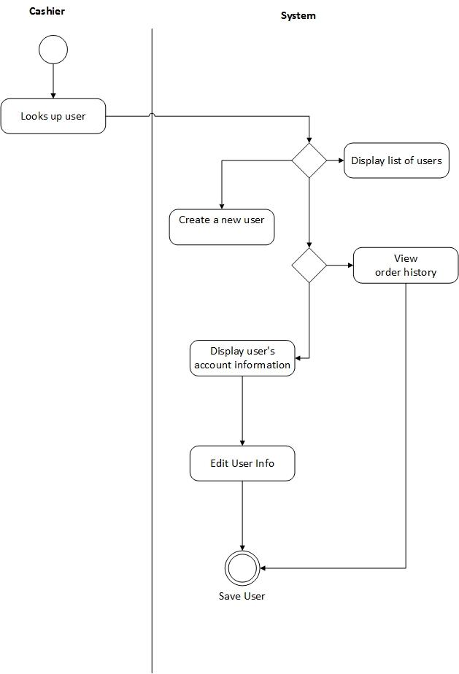

**+ Deployment View: Deployment Diagram**

Process Rental

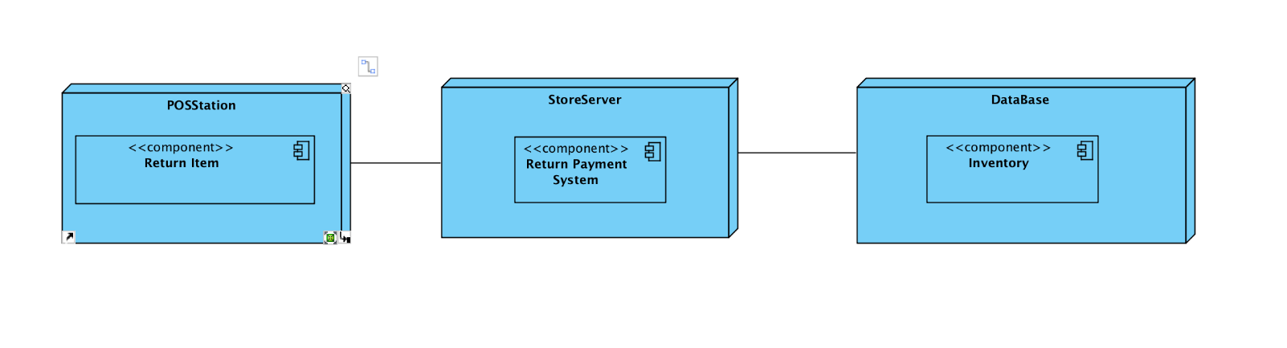

**+Responsibility Matrix**

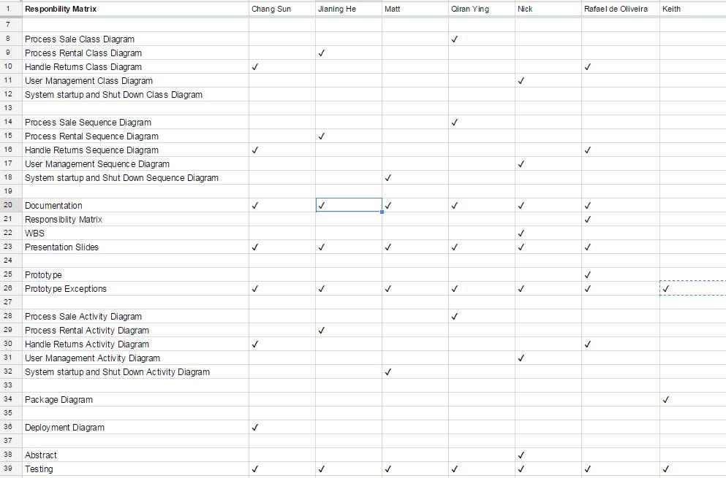

**+Work Breakdown Structure**

